Seaworld text

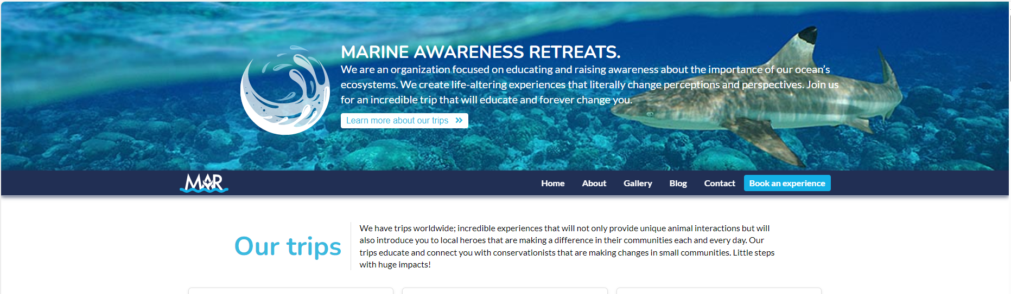

MARINE AWARENESS RETREATS.

We are an organization focused on educating and raising awareness about the importance of our ocean’s ecosystems. We create life-altering experiences that literally change perceptions and perspectives. Join us for an incredible trip that will educate and forever change you.

Our trips

We have trips worldwide; incredible experiences that will not only provide unique animal interactions but will also introduce you to local heroes that are making a difference in their communities each and every day. Our trips educate and connect you with conservationists that are making changes in small communities. Little steps with huge impacts!

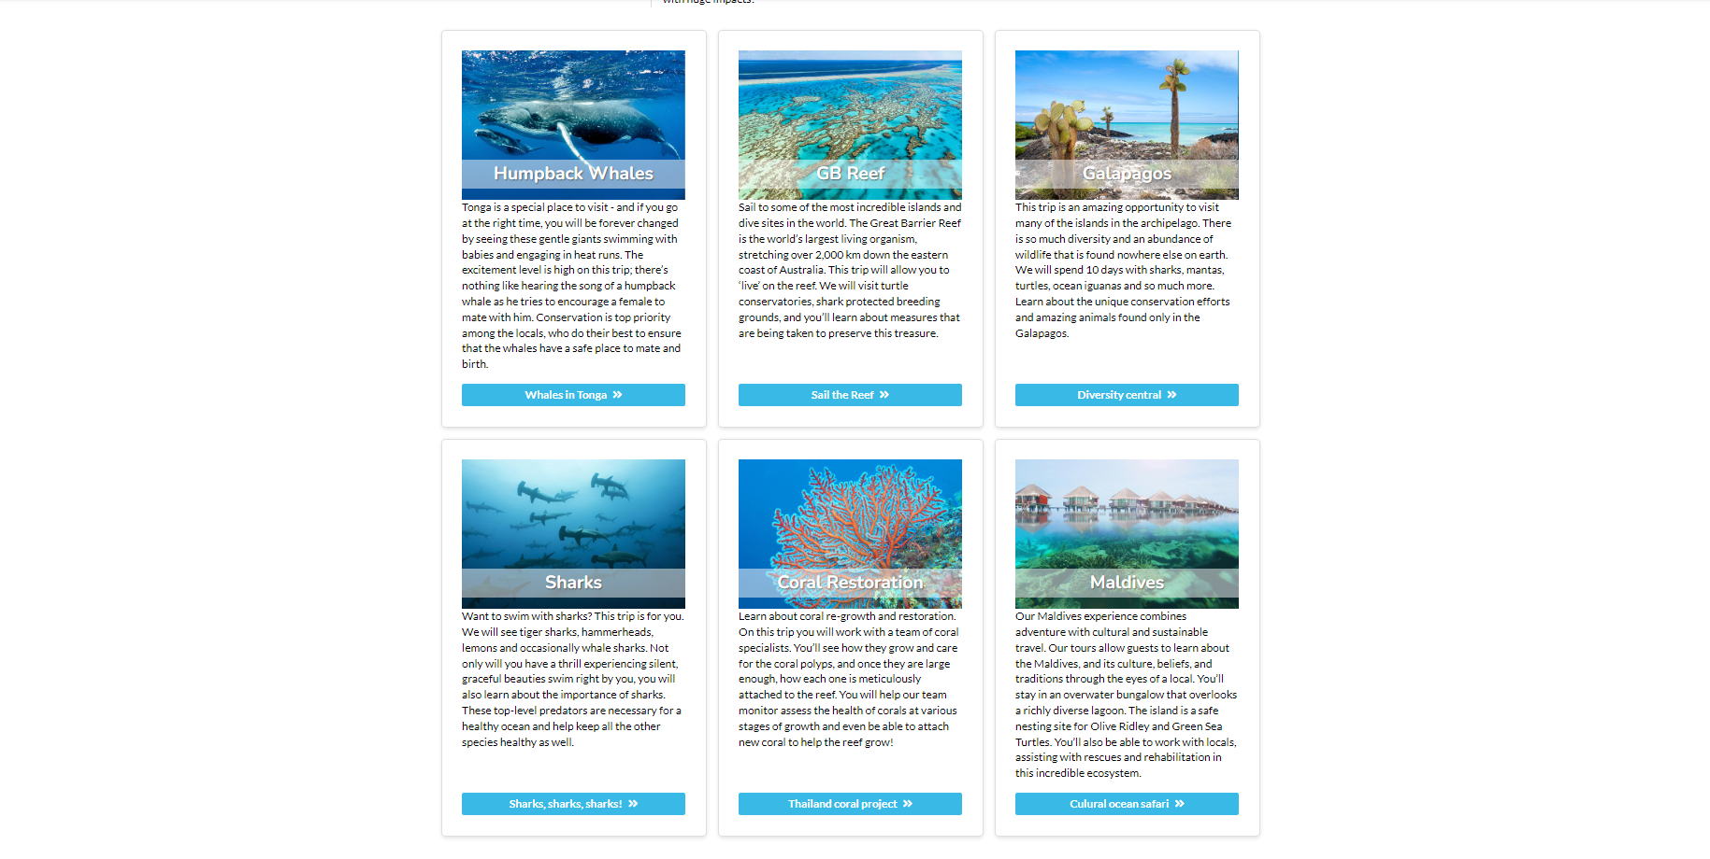

Humpback Whales

Tonga is a special place to visit - and if you go at the right time, you will be forever changed by seeing these gentle giants swimming with babies and engaging in heat runs. The excitement level is high on this trip; there’s nothing like hearing the song of a humpback whale as he tries to encourage a female to mate with him. Conservation is top priority among the locals, who do their best to ensure that the whales have a safe place to mate and birth.

GB Reef

Sail to some of the most incredible islands and dive sites in the world. The Great Barrier Reef is the world’s largest living organism, stretching over 2,000 km down the eastern coast of Australia. This trip will allow you to ‘live’ on the reef. We will visit turtle conservatories, shark protected breeding grounds, and you’ll learn about measures that are being taken to preserve this treasure.

Galapagos

This trip is an amazing opportunity to visit many of the islands in the archipelago. There is so much diversity and an abundance of wildlife that is found nowhere else on earth. We will spend 10 days with sharks, mantas, turtles, ocean iguanas and so much more. Learn about the unique conservation efforts and amazing animals found only in the Galapagos.

Sharks

Want to swim with sharks? This trip is for you. We will see tiger sharks, hammerheads, lemons and occasionally whale sharks. Not only will you have a thrill experiencing silent, graceful beauties swim right by you, you will also learn about the importance of sharks. These top-level predators are necessary for a healthy ocean and help keep all the other species healthy as well.

Coral Restoration

Learn about coral re-growth and restoration. On this trip you will work with a team of coral specialists. You’ll see how they grow and care for the coral polyps, and once they are large enough, how each one is meticulously attached to the reef. You will help our team monitor assess the health of corals at various stages of growth and even be able to attach new coral to help the reef grow!

Maldives

Our Maldives experience combines adventure with cultural and sustainable travel. Our tours allow guests to learn about the Maldives, and its culture, beliefs, and traditions through the eyes of a local. You’ll stay in an overwater bungalow that overlooks a richly diverse lagoon. The island is a safe nesting site for Olive Ridley and Green Sea Turtles. You’ll also be able to work with locals, assisting with rescues and rehabilitation in this incredible ecosystem.

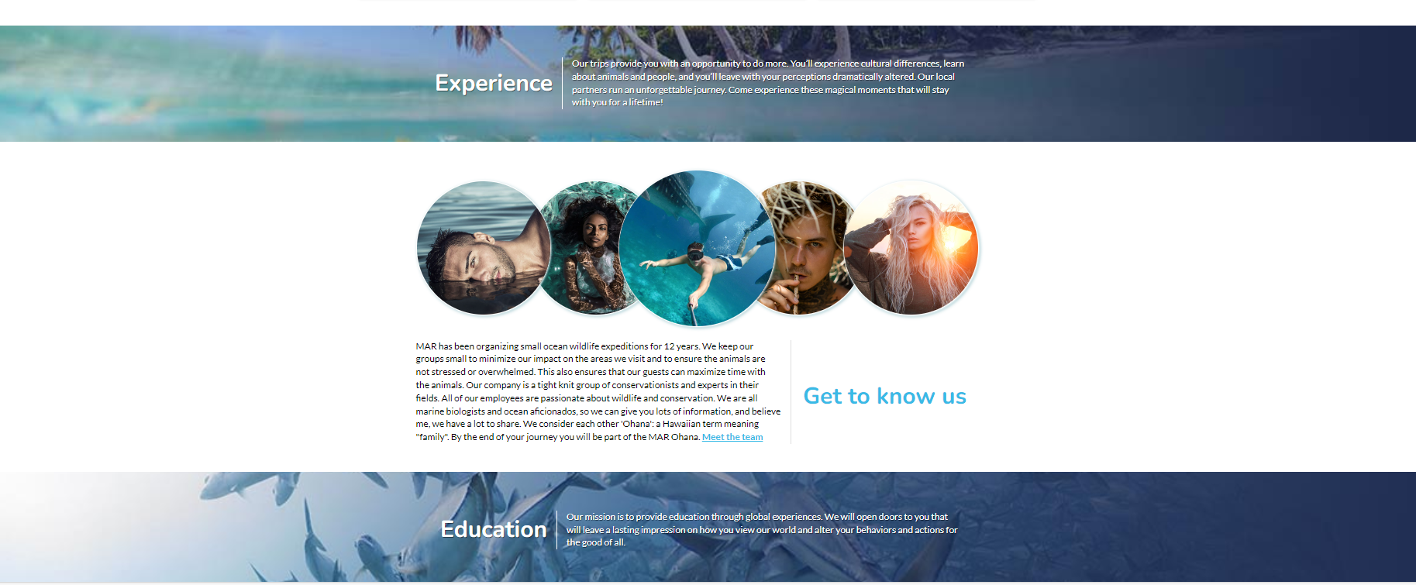

Experience

Our trips provide you with an opportunity to do more. You’ll experience cultural differences, learn about animals and people, and you’ll leave with your perceptions dramatically altered. Our local partners run an unforgettable journey. Come experience these magical moments that will stay with you for a lifetime!

Get to know us

MAR has been organizing small ocean wildlife expeditions for 12 years. We keep our groups small to minimize our impact on the areas we visit and to ensure the animals are not stressed or overwhelmed. This also ensures that our guests can maximize time with the animals. Our company is a tight knit group of conservationists and experts in their fields. All of our employees are passionate about wildlife and conservation. We are all marine biologists and ocean aficionados, so we can give you lots of information, and believe me, we have a lot to share. We consider each other 'Ohana': a Hawaiian term meaning "family". By the end of your journey you will be part of the MAR Ohana. Meet the team

Education

Our mission is to provide education through global experiences. We will open doors to you that will leave a lasting impression on how you view our world and alter your behaviors and actions for the good of all.



We have a plastic problem

Our oceans are facing growing challenges from pollution, habitat loss, development, and climate change. The impact of plastic and micro-plastics to our seas is outrageous and devastating for many species. Learn more about what you can do to stop it.

Here are just a few chilling facts:

It is estimated that by 2050, oceans will carry more plastic mass than fish

Plastic waste kills up to 1 million sea birds, 100,000 sea mammals, marine turtles and countless fish each year

80% of all pollution in seas and oceans comes from land-based activities

It's not just animals: people are consuming micro plastics too. Ewwww!

A garbage truck’s worth of plastic is dumped into the ocean every single minute

Take action right now!

For a healthy planet, we need healthy oceans. Oceans cover 70% of the earth’s surface and they are seriously under threat. We all need to do our part. Here are some things you can do right now:

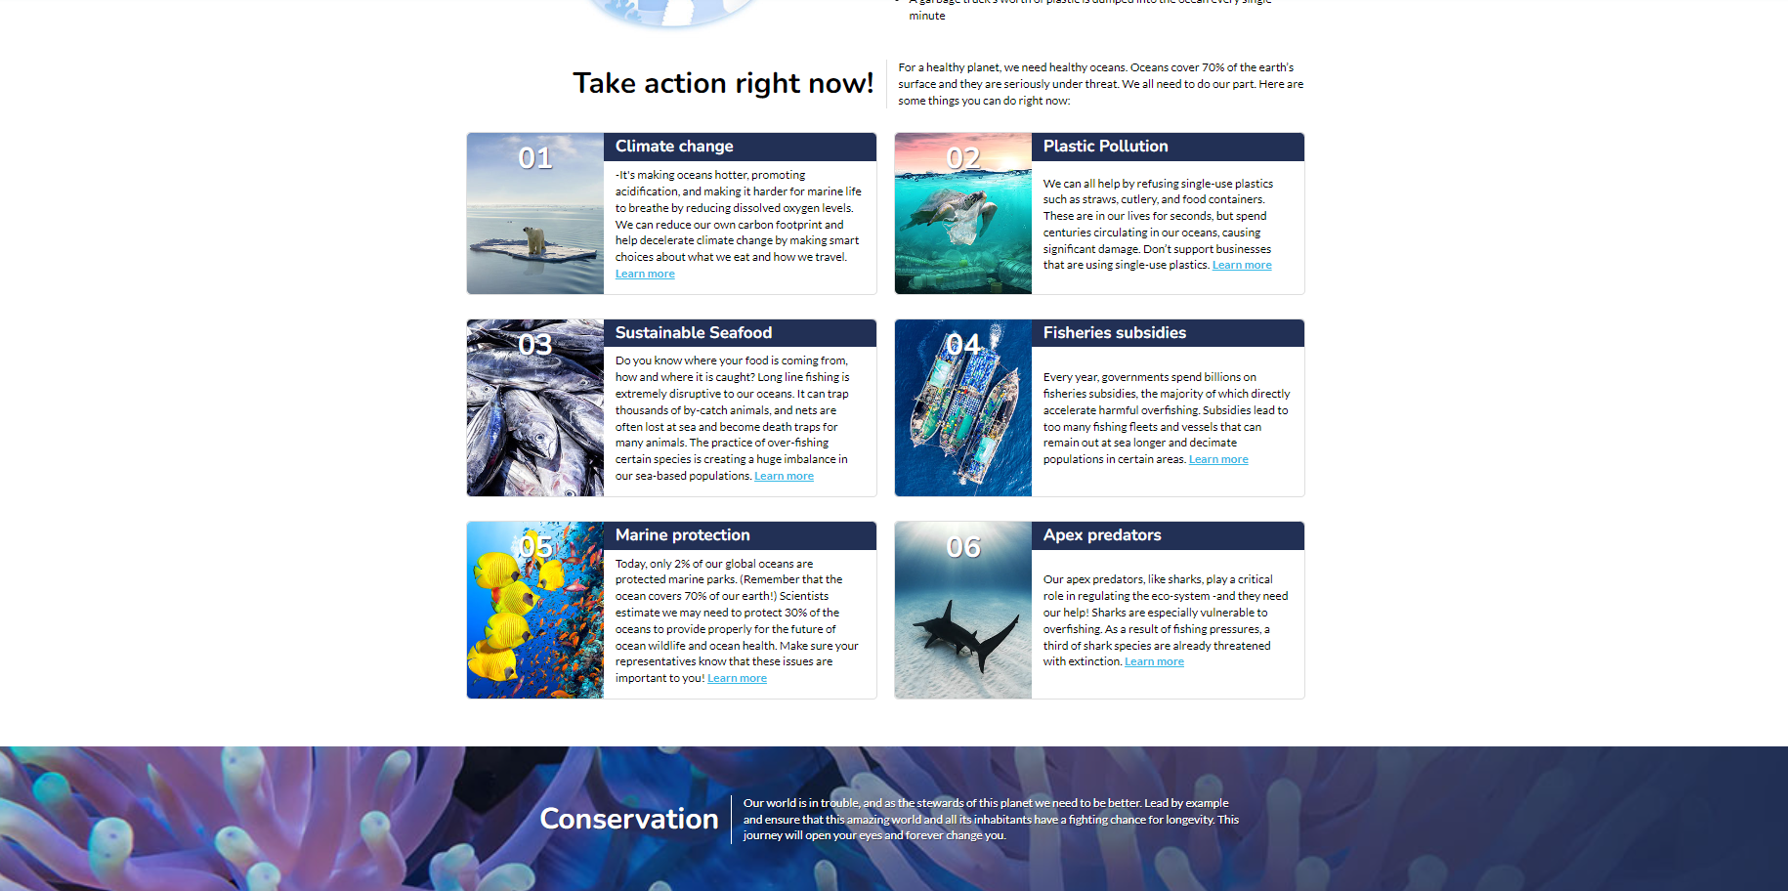

Climate change

-It's making oceans hotter, promoting acidification, and making it harder for marine life to breathe by reducing dissolved oxygen levels. We can reduce our own carbon footprint and help decelerate climate change by making smart choices about what we eat and how we travel. Learn more

Plastic Pollution

We can all help by refusing single-use plastics such as straws, cutlery, and food containers. These are in our lives for seconds, but spend centuries circulating in our oceans, causing significant damage. Don’t support businesses that are using single-use plastics. Learn more

Sustainable Seafood

Do you know where your food is coming from, how and where it is caught? Long line fishing is extremely disruptive to our oceans. It can trap thousands of by-catch animals, and nets are often lost at sea and become death traps for many animals. The practice of over-fishing certain species is creating a huge imbalance in our sea-based populations. Learn more

Fisheries subsidies

Every year, governments spend billions on fisheries subsidies, the majority of which directly accelerate harmful overfishing. Subsidies lead to too many fishing fleets and vessels that can remain out at sea longer and decimate populations in certain areas. Learn more

Conservation

Our world is in trouble, and as the stewards of this planet we need to be better. Lead by example and ensure that this amazing world and all its inhabitants have a fighting chance for longevity. This journey will open your eyes and forever change you.

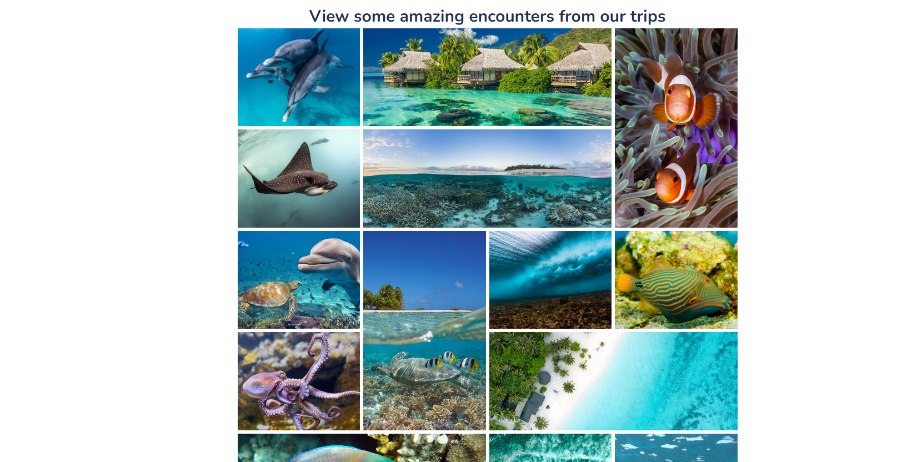

View some amazing encounters from our trips

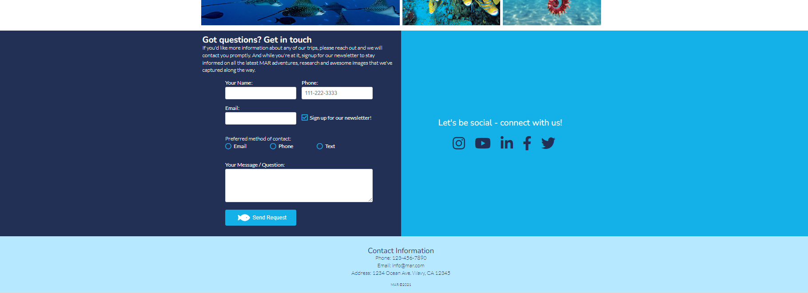

Got questions? Get in touch

If you'd like more information about any of our trips, please reach out and we will contact you promptly. And while you're at it, signup for our newsletter to stay informed on all the latest MAR adventures, research and awesome images that we've captured along the way.

Contact Information

Phone: 123-456-7890

Email: info@mar.com

Address: 1234 Ocean Ave. Wavy, CA 12345

MAR ©2024